Chapter 6 homework

- Complete exercises
  - 6.15(a.-e., g.)
    - For a: Do box and dot plots instead and include Y
    - For d: Skip
    - For e: Use the semi-studentized residuals; do not examine the two-factor interaction; include a histogram with normal distribution overlay
    - For f: Skip
    - For g: Do Levene's test as well (once for each predictor variable - there is not a good way to divide the data)
    - Also, perform the Box-Cox procedure and comment on its results
    - You may use examine.mod.multiple.R to help answer this problem
  - 6.16
  - 6.17
  - 6.30
    - For a: Do box and dot plots instead
    - For d.: Also calculate and interpret the adjusted R2
    - For e.: Don't do the two factor interaction plots
    - You may use examine.mod.multiple.R to help answer this problem.
  - Additional parts for 6.30:
- In one particular regression model building procedure, the k^{th} variable is removed from the regression model if a t-test for β_{k} does not reject H_{o}. For model #2, notice that facilities is not significantly related to stay. Remove this variable from the model and find the new model. Use this model for the rest of these problems. Calculate R² and 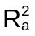. What happens to these measures?
- Create the same plots as done for #6.30e. Note that you will no longer have a plot for e_{i} vs. facilities. What happens to these plots for the new model?
- Using scatterplot3d(), create a scatter plot for the variables beds, infection, and stay with the sample regression plane plotted upon it.
- Using scatter3d(), create an interactive scatter plot for the variables beds, infection, and stay with the sample regression plane plotted upon it.
- Create the correct plot to formally show that observation #47 and #112 are outliers. Remove these observations from the data set and repeat the analyses for 1.-5. What differences do you notice?
- Examine tests from 2012
- Reproduce all examples in the notes

Partial answers:

I completed these homework problems before writing the examine.mod.multiple() function so you will not see it implemented here.

6.15

a. No unusual observations
b.
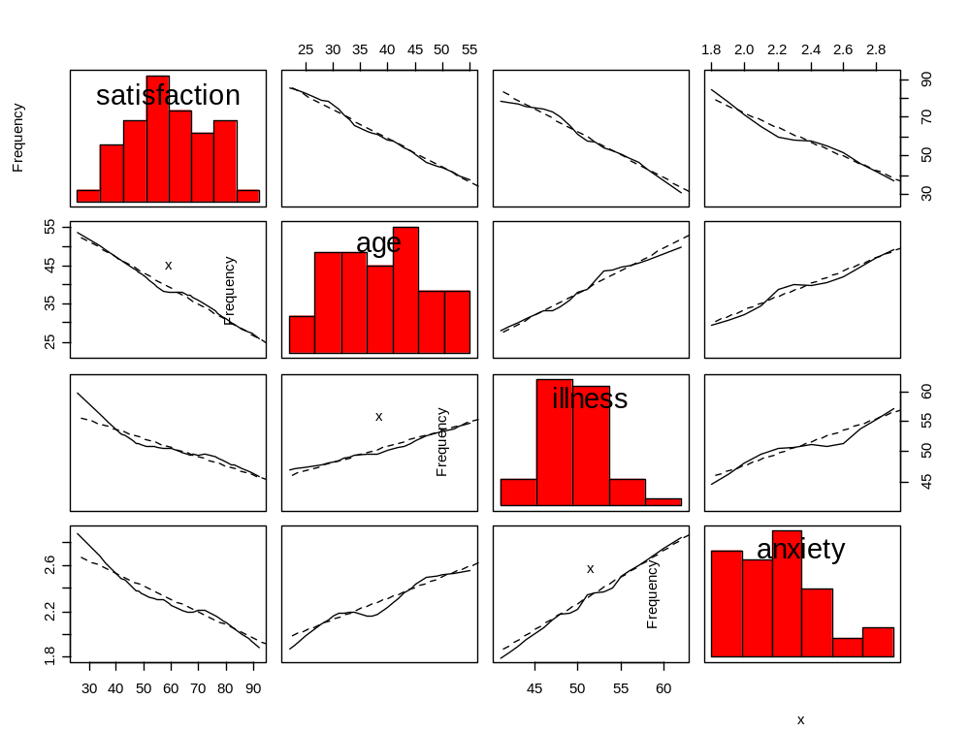

> library(car)
> scatterplotMatrix(x = ~satisfaction+age+illness+anxiety, data=patient,
reg.line=lm, smooth=TRUE, span=0.5, diagonal = 'histogram')

> round(cor(x = patient, method = "pearson"),4)
satisfaction age illness anxiety
satisfaction 1.0000 -0.7868 -0.6029 -0.6446
age -0.7868 1.0000 0.5680 0.5697
illness -0.6029 0.5680 1.0000 0.6705
anxiety -0.6446 0.5697 0.6705 1.0000

Some moderate to large correlations.

c.

> mod.fit<-lm(formula = satisfaction ~ age + illness + anxiety, data = patient)
> sum.fit<-summary(mod.fit)
> sum.fit

Call:
lm(formula = satisfaction ~ age + illness + anxiety, data = patient)

Residuals:
Min 1Q Median 3Q Max
-18.3524 -6.4230 0.5196 8.3715 17.1601

Coefficients:
Estimate Std. Error t value Pr(>|t|)
(Intercept) 158.4913 18.1259 8.744 5.26e-11 ***
age -1.1416 0.2148 -5.315 3.81e-06 ***
illness -0.4420 0.4920 -0.898 0.3741
anxiety -13.4702 7.0997 -1.897 0.0647 .
---
Signif. codes: 0 '***' 0.001 '**' 0.01 '*' 0.05 '.' 0.1 ' ' 1

Residual standard error: 10.06 on 42 degrees of freedom
Multiple R-Squared: 0.6822, Adjusted R-squared: 0.6595
F-statistic: 30.05 on 3 and 42 DF, p-value: 1.542e-10

The sample model is where Y = satisfaction, X₁ = age, X₂ = illness, and X₃ = anxiety.

For every one unit increase in the illness index, the satisfaction score is estimated to decrease by 0.4420, holding the other variables constant.

e.
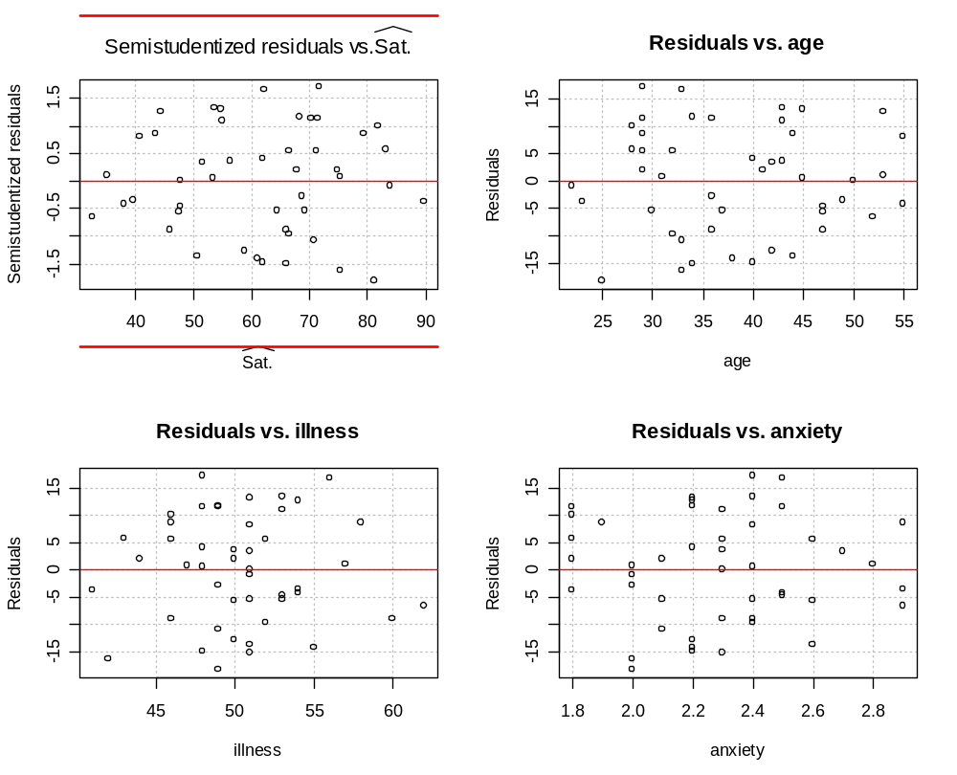

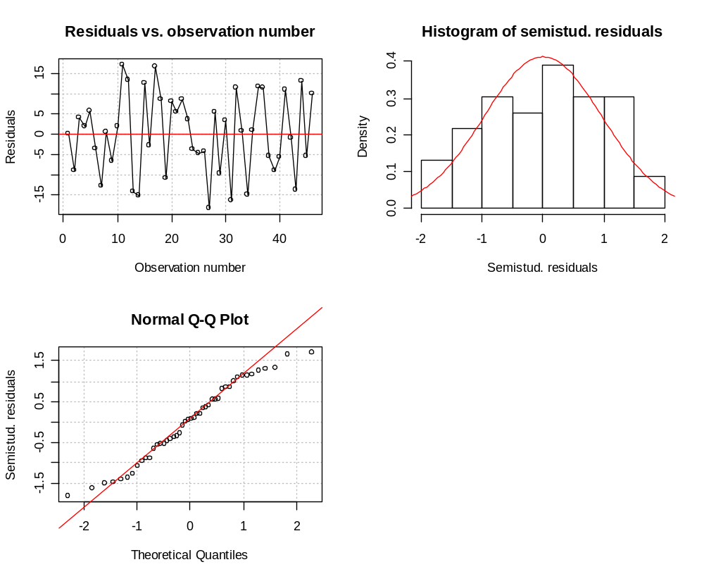
One should formally go through all of the items as listed in the Section 3.11 of the notes. I will informally say that everything looks o.k except for some possible deviation from normality on the tails of the semistudentized residual distribution.

g. There is not a good way to implement Levene’s test due to the three predictor variables so I decided to use each predictor variable to help divide the data into groups.

> library(car)
> group<-ifelse(patient$age < median(patient$age), 1, 2)
> levene.test(y = mod.fit$residuals, group = group)
Levene's Test for Homogeneity of Variance
Df F value Pr(>F)
group 1 0.9012 0.3477
44

> group<-ifelse(patient$illness < median(patient$illness), 1, 2)
> levene.test(y = mod.fit$residuals, group = group)
Levene's Test for Homogeneity of Variance
Df F value Pr(>F)
group 1 5.734e-06 0.9981
44

> group<-ifelse(patient$anxiety < median(patient$anxiety), 1, 2)
> levene.test(y = mod.fit$residuals, group = group)
Levene's Test for Homogeneity of Variance
Df F value Pr(>F)
group 1 0.3887 0.5362
44

> library(lmtest)
> bptest(formula = satisfaction ~ age + illness + anxiety, data = patient,
studentize = FALSE) #KNN Version of the test

Breusch-Pagan test
data: satisfaction ~ age + illness + anxiety
BP = 1.2516, df = 3, p-value = 0.7407

Overall, the tests do not reject constant variance.

The Box-Cox results (not shown) contain 1 in its C.I. suggesting that non transformation may be needed. Given the results in the residuals vs.  plot, this seems reasonable.

6.16 From the answer key:
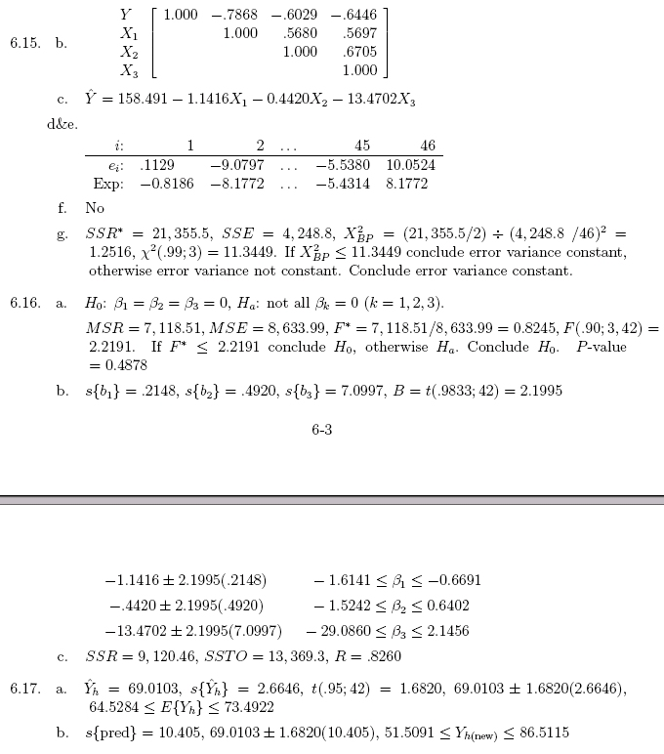
The answer key appears to be wrong for part a and c. I obtain a F* = 30.05 and R² = 0.6822, for example.

> mod.fit<-lm(formula = satisfaction ~ age + illness + anxiety, data = patient)
> sum.fit<-summary(mod.fit)
> sum.fit

Call:
lm(formula = satisfaction ~ age + illness + anxiety, data = patient)

Residuals:
Min 1Q Median 3Q Max
-18.3524 -6.4230 0.5196 8.3715 17.1601

Coefficients:
Estimate Std. Error t value Pr(>|t|)
(Intercept) 158.4913 18.1259 8.744 5.26e-11 ***
age -1.1416 0.2148 -5.315 3.81e-06 ***
illness -0.4420 0.4920 -0.898 0.3741
anxiety -13.4702 7.0997 -1.897 0.0647 .
---
Signif. codes: 0 '***' 0.001 '**' 0.01 '*' 0.05 '.' 0.1 ' ' 1

Residual standard error: 10.06 on 42 degrees of freedom
Multiple R-Squared: 0.6822, Adjusted R-squared: 0.6595
F-statistic: 30.05 on 3 and 42 DF, p-value: 1.542e-10

> anova.fit<-anova(mod.fit)
> anova.fit
Analysis of Variance Table

Response: satisfaction
Df Sum Sq Mean Sq F value Pr(>F)
age 1 8275.4 8275.4 81.8026 2.059e-11 ***
illness 1 480.9 480.9 4.7539 0.03489 *
anxiety 1 364.2 364.2 3.5997 0.06468 .
Residuals 42 4248.8 101.2

> ssr<-sum(anova.fit$"Sum Sq"[1:3])
> mse<-anova.fit$"Mean Sq"[4]
> F.star<-ssr/(length(mod.fit$coefficients)-1)/mse #F.star
> data.frame(ssr, mse, msr = ssr/(length(mod.fit$coefficients)-1), F.star)
ssr mse msr F.star
1 9120.464 101.1629 3040.155 30.05208
> sse<-anova.fit$"Sum Sq"[4]
> sse+ssr #SSTO
[1] 13369.30

Part b’s answer is correct

> alpha<-0.10
> g<-3
> confint(object = mod.fit, level = 1-alpha/g) #6.16b
1.67 % 98.33 %
(Intercept) 118.607631 198.3748720
age -1.614248 -0.6689755
illness -1.524510 0.6405013
anxiety -29.092028 2.1517012

I think the problem may be that this problem in their 1996 book edition had only 23 observations. For some reason, they added 23 more observations to their 2004 book edition and may have not checked some of their results.

6.17 From the answer key:
> new.patient<-data.frame(age = 35, illness = 45, anxiety = 2.2)
> predict(object = mod.fit, newdata = new.patient, interval = "confidence", level
= 0.90)
fit lwr upr
[1,] 69.01029 64.52854 73.49204

> predict(object = mod.fit, newdata = new.patient, interval = "prediction", level
= 0.90)
fit lwr upr
[1,] 69.01029 51.50965 86.51092

6.30 Throughout this problem, the same two observations as found in Chapter 3, #47 and #112, are shown as outliers. These are the only potential problems that I can find with the model.

a.
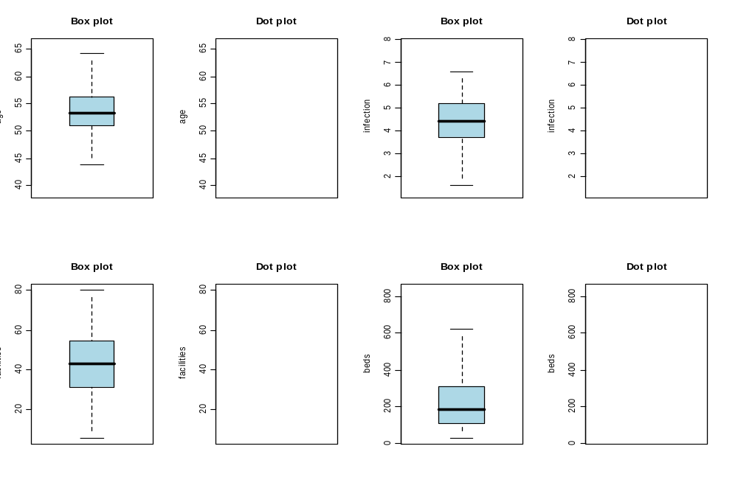

- Beds and facilities have the largest correlation at 0.7945. While this probably is not high enough to cause potential problems with multicolinearity (discussed in Chapter 11), I would not be surprised to find only one, not both, variables would be needed in a model.
- First-order regression – see p. 215. We will discuss squared terms and interactions later in Chapter 8 (even though they are introduced in Chapter 6).
- Do on your own.
- Just #47 and 112 stand out

Supplementary problems that continue working with this data set

1. Part of the R output needed to answer the question:

Call:
lm(formula = stay ~ beds + infection, data = senic)

Residuals:
Min 1Q Median 3Q Max
-2.8624 -0.9904 -0.1996 0.6671 8.4219

Coefficients:
Estimate Std. Error t value Pr(>|t|)
(Intercept) 6.2703521 0.5038751 12.444 < 2e-16 ***
beds 0.0024747 0.0008236 3.005 0.00329 **
infection 0.6323812 0.1184476 5.339 5.08e-07 ***
---
Signif. codes: 0 '***' 0.001 '**' 0.01 '*' 0.05 '.' 0.1 ' ' 1

Residual standard error: 1.568 on 110 degrees of freedom
Multiple R-Squared: 0.3388, Adjusted R-squared: 0.3268
F-statistic: 28.19 on 2 and 110 DF, p-value: 1.310e-10

2. Do on your own.

3. Partial answer: The plots should appear about the same.

4. and 5. code

library(scatterplot3d)
win.graph(width = 6, height = 6, pointsize = 10)
save.plot<-scatterplot3d(x = senic$beds, y = senic$infection, z = senic$stay,
main = "3D scatterplot for senic data", xlab = "beds", ylab =
"infection", zlab = "stay", type = "h", pch=16, highlight.3d=TRUE,
angle=55, lwd = 2)
save.plot$plane3d(mod.fit2.2, lty.box = "solid", col = "blue")

library(Rcmdr)
library(rgl)
rgl.clear("all") #Clears plot window
rgl.light() #Gray background
rgl.bbox() #Puts numbers on plot and box around it
scatter3d(x = senic$beds, y = senic$stay, z = senic$infection,
fit="linear", grid=TRUE, xlab="beds", ylab="stay", zlab="infection",
bg.col="black")

6. Partial answer

> #Without two observations
> mod.fit2.2$coefficients
(Intercept) beds infection
6.785292872 0.001694970 0.527888863

> #With all observations
> mod.fit2.2old$coefficients
(Intercept) beds infection
6.270352063 0.002474661 0.632381152

